Algebra

Common Interim Assessment #3

2015-2016

Name: ____________________________________________________

School: ____________________________________________________

Teacher: ___________________________________________________

1. Corrine is planning a beach vacation in July and is analyzing the daily temperatures for her potential destination. She would like to choose a destination with a high median temperature and a small interquartile range. She constructed box plots shown in the diagram below.

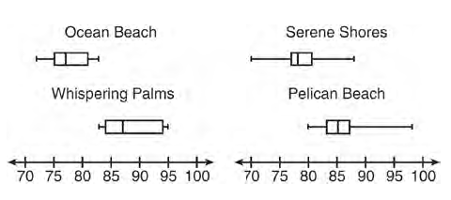

Which destination has a median temperature above 80- degrees and the smallest interquartile range?

* 1. Ocean Beach
  2. Whispering Palms
  3. Serene Shores
  4. Pelican Beach

1. The table below shows the average diameter of a pupil in a person’s eye as he or she grows older.

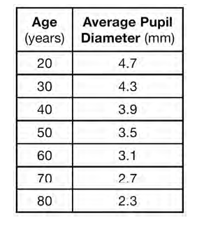

What is the average rate of change, in millimeters per year, of a person’s pupil from age 20 to age 80?

* 1. 2.4
  2. 0.04
  3. -2.4
  4. -0.04

1. What is the value of *x* in the equation?
   1. 4
   2. 6
   3. 8
   4. 11
2. The value of the x-intercept for the graph of is
   1. 10
   2. -8
   3. 
   4. 
3. A satellite television company charges a one-time installation fee and a monthly service charge. The total cost is modeled by the function . Which statement represents the meaning of each part of the function?
   1. *y* is the total cost, *x* is the number of months of service, $90 is the installation fee, and $40 is the service charge per month.
   2. *y* is the total cost, *x* is the number of months of service, $40 is the installation fee, and $90 is the service charge per month.
   3. *x* is the total cost, y is the number of months of service, $40 is the installation fee, and $90 is the service charge per month.
   4. *x* is the total cost, y is the number of months of service, $90 is the installation fee, and $40 is the service charge per month.
4. Keith determines the zeros of the function to be -6 and 5. What could be Keith’s function?
   1. 
   2. 
   3. 
   4. 
5. Which equation has the same solution as?
   1. 
   2. 
   3. 
   4. 
6. Max purchased a box of green tea mints. The nutrition label on the box stated that a serving of three mints contains a total of 10 Calories. On the axes below, graph the function, *C*, where *C(x)* represents the number of Calories in *x* mints.

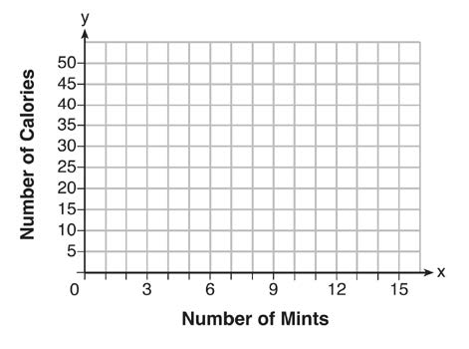

Part b: Write an equation that represents *C(x)*.

Part c: A full box of mints contains 180 Calories. Use the equation to determine the total number of mints in the box.

1. Solve the equation algebraically for *x.*
2. Express the product of and in standard form
3. A company is considering building a manufacturing plant. They determine the weekly production cost at site *A* to be while the production cost at site *B* is__________ , where *x* represents the number of products, *in hundreds*, and and are the production costs, *in hundreds of dollars*. Graph the production cost functions on the set of axes below and label them site *A* andsite *B.*

