MASTERY CHECK
NAME: ______________________________________ Solving Inequalities
DATE: _______________________________________ Section 7-2 MASTERY CHECK
Choose the correct inequality that best describes each graph.
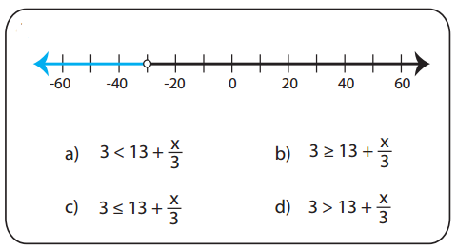 | 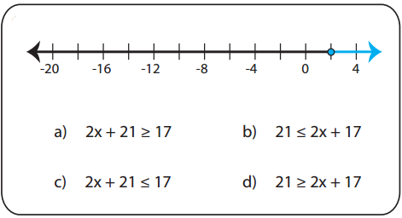
Choose the correct graph that best describes the solution for each inequality.
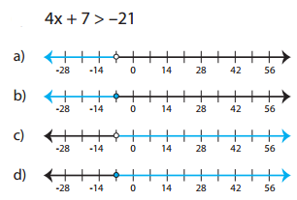 | 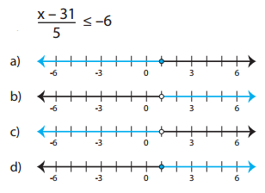
Solve and Graph
