Wabbit TI-84 Plus Silver Edition Emulator Instructions

Go to the following website to download the operating system (OS 2.53 MP):
http://education.ti.com/calculators/downloads/US/Software/Detail?id=6014&ref=%2fcalculators%2fdownloads%2fUS%2fSoftware%2fSearch%2fResults%3fcp%3d2%23view-1.

Save the operating system on your computer.

Go to this website http://wabbit.codeplex.com.
Download Wabbitemu. You will be asked to agree to the license.
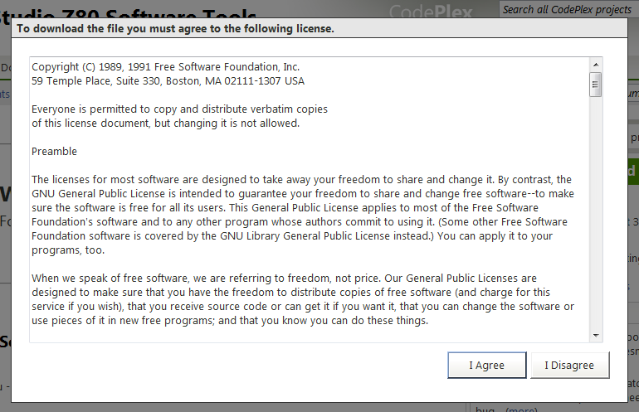

Run Wabbitemu.exe
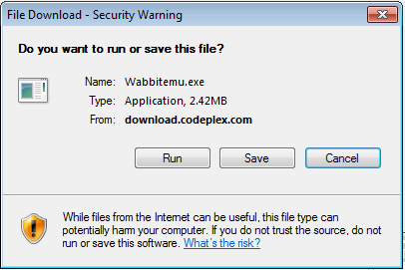

Select “Create a ROM image using open source software.”

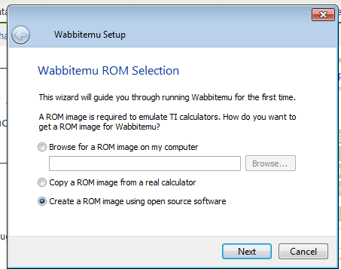

Select Calculator Type TI-84 Plus SE.

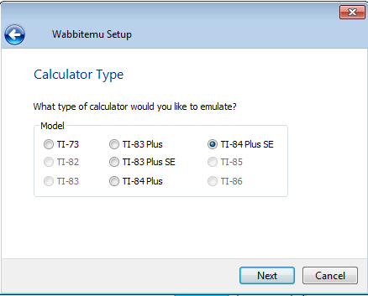

OS Selection – Browse for TI-84 Plus OS file you saved on your computer.
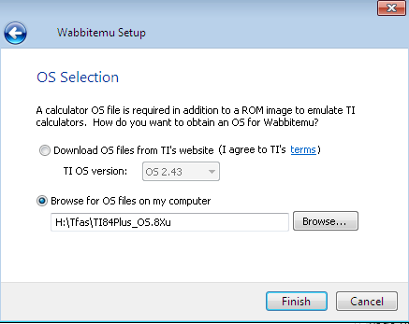

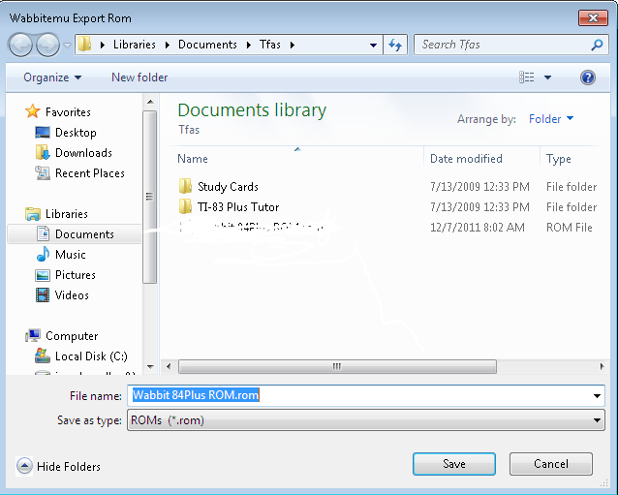
Save as a ROM file (I named mine Wabbit84PlusROM).
The Wabbitemu should appear From the View Menu,
on your desktop. select “Enable skin.”

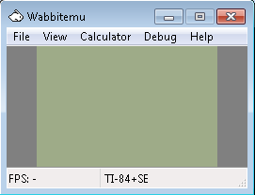

The Wabbitemu appears Turn On the emulator.
on your desktop.

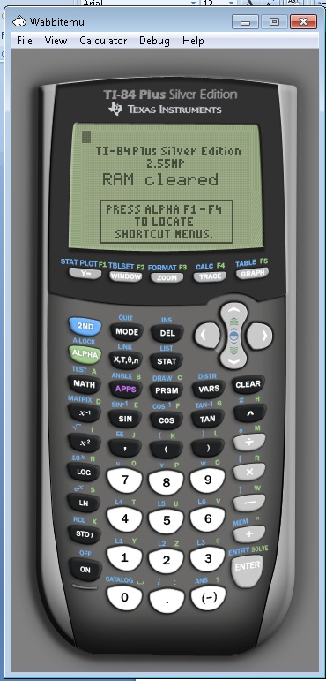

Right click on the white rabbit. Select “Pin this program to the taskbar.”

If you are successful, the Wabbitemu Emulator icon changes from a white rabbit to a calculator with rabbit on your taskbar.

Click on the icon to use the emulator.

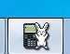

Webpage: http://www.bcs1.org/webpages/hsmath/ti-84.cfm

